**ABSTRACT**

The main agenda of this project is to provide facilities regarding to cleaning in Indore.Our website will provide facilities such as “complaints against dirty places”, keep tracking on status of complains”,Providing information about clean and dirty areas in Indore” etc.Website will also provide all schemes of government that comes under clean India project.The main idea of making this project is discovered when we saw people are facing problems such as no one is properly taking actions of their complaints,moreover its headache as well as time consuming when common people has to go to municipal corporation just to complain for cleaning.As we know in today’s life everyone has smartphones, computer and laptop, so by using this website they can save their time as website will be available always. By connecting with us is same like connecting with the municipal corporation but in open and in advanced way.Our project’s main focus is to help Indore citizens in cleaning and being healthy because “We won’t have the society if we don’t take care the environment and destroy it”.

**Table of Contents**

**CHAPTER 1 : Introduction 8-9**

1.1 Overview and issues involved.8

1.2 Problem Definition. 8

1.3 Proposed Solution. 9

**CHAPTER-2 : Literature Survey 10-11**

2.1 Methodology 10

2.2 Technology and Tools to be used. 10

2.3 Existing Solutions. 11

**CHAPTER 3 : Analysis 11-14**

3.1 Software Requirements 11

3.2 hardware requirements 11

3.3 Use Case 12

3.4 Use Case description 13

**CHAPTER 4 : Design 15-21**

4.1 Technology Selection 15

4.2 Sequence Diagram 16

4.3 Class Diagram 20

4.4 E-R Diagram 21

**CHAPTER 5: Implementation and testing 22**

**CHAPTER 6: Conclusion 23**

**References 24**

**CHAPTER-1INTRODUCTION**

**1.1 Overview and issues involved**

Our idea is to make a well defined web page portal which will provide information about all schemes of government under clean India project. It will also provide transparency in the government schemes and how they are implementing them. We have made a website which will be available 24/7. This website is not only going to help the people of Indore to be aware about city’s cleaning but also providing facility to register their complains related to cleaning in their areas. People will be able to check their status of complaint and other people can see status of those areas which are already cleaned. Areas which are still in process of cleaning, Areas which are dirty as well. In the website there are three zones of Indore is divided as Green Zone,Blue Zone,Red Zone that indicates status ‘Cleaned’, Cleaning is not urgently and in the process of cleaning’, Dirty Zone where cleaning is needed’. We will keep up to date our website to provide information nearly like real time information. People can also fill up feedback form about our work,about technical issues, about cleaning issues etc.

**1.2 Problem definition**

In today’s modern world the cleaning facilities are needed to be upgraded and digitized because it is not possible to provide cleaning facilities to each individual personally. It is very time consuming as well as very old method which might be not economically feasible for large number of population.

It is not possible to make people aware about the cleaning by distributing the pamphlets and posters. Unlike the old way of awareness today’s modern generation needs a digital platform which is easily accessible. Nowadays everything is digitalized and everyone is so busy in their hectic life schedule, nobody has the time or interest to go to city municipal office and register complain regarding to cleaning problem in their area. Furthermore no one really knows the actual facilities that government has issued for us hence we won’t be able to take the proper benefits of them.

Normally everyone thinks that they know everything about cleaning but they don't. People throw garbage and trash everywhere without even thinking. Some people just think about cleaning their own houses and colony and throw their household garbage on some other place and eventually they are polluting their own city or country. If any empty plastic bottle or plastic bag is available in public places then no one throws it in dustbin. People do not understand their responsibility. Being a Computer Engineer we will try our best to make people aware about cleaning and provide them a digital way for cleaning what they needed.

**1.3Proposed Solution**

In this project we have used PHP, HTML, Database of MySQL. We used PHP coding because it’s a very vast and encapsulated language,easy to understand,ease in use,easy to implement which is platform independent, HTML is used for displaying the Webpage, Database system is used to store the collected information in an organized manner. This website will help in fast communication between the Municipal Corporation and common people.

For making this webpage, firstly we will visit municipal office and gather all the information about government policies under clean India project and how they are applying them in Indore, later we will collect information of all the areas in Indore. After collecting we will analyse it and divide areas of Indore in three categories so that people can easily get information about any area of Indore.

We are also providing a platform where anyone can easily file any complaint for cleaning in their area and they can also share their ideas that might become beneficial for both people and government.

**CHAPTER-2 LITERATURE SURVEY**

**2.1 Methodology**

As far as our project is concerned we have no special algorithm or methodology is involved in it.So, we have decided to make it simple but very useful and helpful.

We have used XAMPP Software with its simple and powerful technology.XAMPP has already Inbuilt configuration of Tomcat Server,MySQL libraries etc.We can easily run our programs on web browsers without any path setup,we just need to install it according to specific requirement of the OS(operating system).

XAMPP : It is afree and open source cross-platform web sever solution stack package developed by Apache Friends,onsisting mainly of theApache HTTP Server andinterpreters for scripts written in thePHP. XAMPP stands for Cross-Platform (X), Apache (A), MariaDB (M), PHP (P) and Perl (P). It is a simple, lightweight Apache distribution that makes it extremely easy for developers to create a local web server for testing and deployment purposes. Everything needed to set up a web server – server application (Apache), database (MariaDB), and scripting language (PHP) – is included in an extractable file. XAMPP is also cross-platform, which means it works equally well on Linux, Mac and Windows. Since most actual web server deployments use the same components as XAMPP, it makes transitioning from a local test server to a live server extremely easy as well.

**2.2 Technologies used :**

**2.2.1 Client Side Scripting / Coding**

Client side scripting is the type of code that is executed or interpreted by browsers. Client side scripting is generally viewable by any visitor to a site (from the view menu click on “view source” to view the source code).

We used these common client side scripting technologies:

1.HTML (Hyper Text Markup Language)

2.CSS (Cascading Style Sheet)

3.JavaScript.

**2.2.2 Server Side Programming**

**Server Side Scripting / Coding –** Server side scripting is the type of code that is executed or interpreted by the web server. Server side scripting is not viewable or accessible by any visitor or general public.

We used these common server side scripting technologies:

* PHP: -PHP is a general purpose, high-level programming language used for backhand coding.
* MYSQL **-** MYSQL is used for Database connectivity.

**2.3Existing solutions:**

We have collected data from various applications related to cleaning and found some common lope holes in every application. So we have decided to cover that lope holes and we did it in our website.We have analysed problems in existing solution applications such as verification code is not receiving properly,problems while submitting data or complaints on the server. Existing applications do not have facilities as we have in our website. We have covered almost everything that is needed to keep Indore clean. Our website is basically specific for Indore only.

**CHAPTER-3 ANALYSIS**

**3.1 Software Requirements**

* Operating System:- Windows XP/Windows7/Windows8/Windows 8.1/Windows 10.
* Database Server:- MYSQL.
* Web Server:- Apache Tomcat.
* Web Browser: Google chrome, Mozilla Firefox, Internet Explorer or any higher version.
* Development environment:- XAMPP
* Back-end Technology:- PHP(Basic) and MySQL.
* Client Side Script:- HTML,CSS,JavaScript

**3.2 Hardware Requirements**

* Processor:- 1.35 GHz or higher
* RAM :- 512 MB RAM.
* Hard Drive:- 1.2 GB free hard disk space.
* Graphics Hardware:- 3D Hardware Accelerator – 64MB of memory minimum DirectX9.0b

**3.2 Use Case Model**

A use case diagram shows a set of use cases and actors and their relationships. Use case diagrams address the static use case view of a system. These diagrams are especially important in organizing and modelling the behaviours of a system. Use case diagrams commonly contains

* Use cases
* Actors
* Dependency, generalization and association relationships

**3. Use Case Diagram**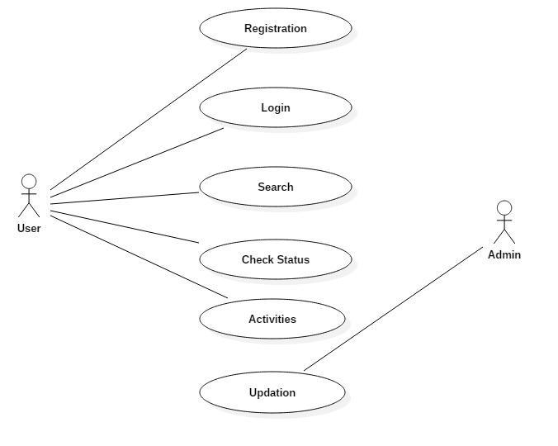

Fig no. 1.1 - Use Case Diagram

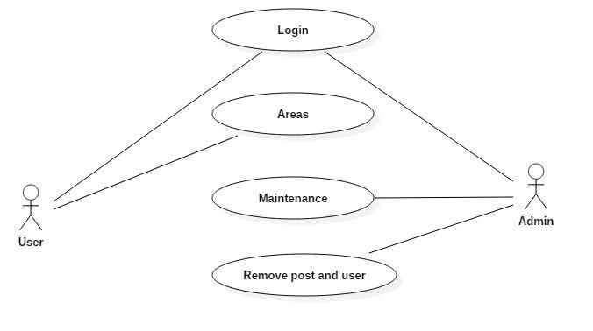

Fig no. 1.2 - Use Case Diagram

**1. User:** Users are concerned with the system and can perform many task such as searching, viewing posts, complaint, checking status etc. Users must have to register and to access all the features of the system.

**2. Admin:**Admin is only the person whose information for accessing website is stored in database. Admin has special aspects for website such as updating status, removing users, posts etc.

Ultimately admin will be responsible for maintaining the website.

**3. Registration:** Only Users can register on the website by filling some information’s such as email, name, password, address etc.

**4. Login:**Users and admin can login and can perform various task.

**5. Search:**Users can search anything which is related to website and its information.

**6. Check Status:** It is the field in which users can check status for areas. Status like, under process, cleaned etc.

**7. Activities:** In this field users can post photos of cleaned areas, cleaned areas (after cleaning) and can see activities of others, can comments on any post etc.

**8. Updation:**Admin is able to update something (deleting, approving etc).

**9. Areas:**Areas field contained information about clean and unclean areas. Clean area indicates Green areas and unclean area indicates Red Areas.

**CHAPTER– 4 DESIGN**

**4.1 Technology Selection**

* Operating System:- Windows XP/Windows7/Windows8/Windows 8.1/Windows 10.
* Database Server:- MYSQL.
* Web Server:- Apache Tomcat.
* Web Browser: Google chrome, Mozilla Firefox, Internet Explorer or any higher version.
* Development environment:- Net beans.
* Back-end Technology:- JAVA(Basic) and JAVA(Advance).
* Client Side Script:- HTML,CSS.
* Processor:- 1.35 GHz or higher.
* RAM :- 512 MB RAM.
* Hard Drive:- 1.2 GB free hard disk space.
* Graphics Hardware:- 3D Hardware Accelerator – 64MB of memory minimum DirectX9.0b

**4.2 Sequence Diagram**

**Defination** : A model describing how groups of objects collaborate in some behaviour over time.

1.The diagram captures the behaviour of a single use case.

2.It shows object and the message that are passed between there object for the particular use case.

**4.2.1 Registration**

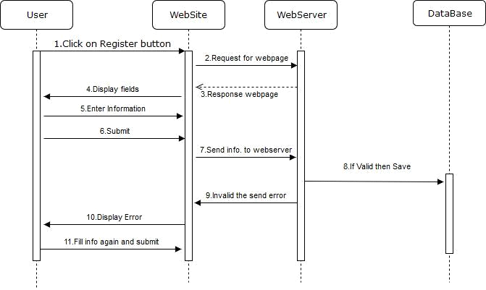

Fig no. 2.1 - Sequence Diagram

**Information about sequence diagram:**

A sequence diagram shows object interactions arranged in time sequence. It depicts the objects and classes involved in the scenario and the sequence of messages exchanged between the objects needed to carry out the functionality of the scenario.

**Registration sequence diagram:**

This above diagram shows internally sequence of registration process, how system will work sequentially when user will click on registration button. There are various things in the diagram such as lifeline of objects, activation boxes, objects, create messages, response messages etc.

**4.2.2 login**

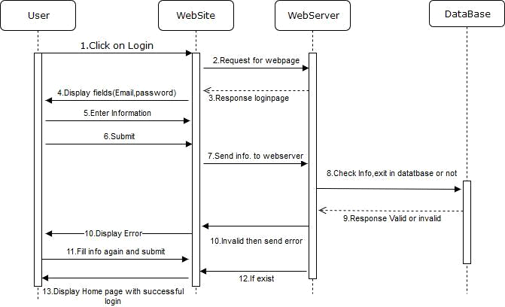

Fig no. 2.2 - Sequence Diagram

**Login sequence diagrams:**

This diagram shows internally sequences of login page, how processes happens internally when user clicks on login button.

**4.2.3 Admin’s Activity**

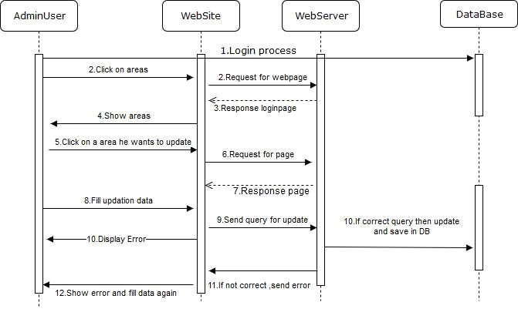

Fig no. 2.3 - Sequence Diagram

**Sequence diagram for admin’s activity :**

Here this diagram shows internal activity of updation that admin does how admin update something and how it works internally is given in above sequence diagram. After updation, data is permanently stored into database.

**4.3 Class Diagrams**

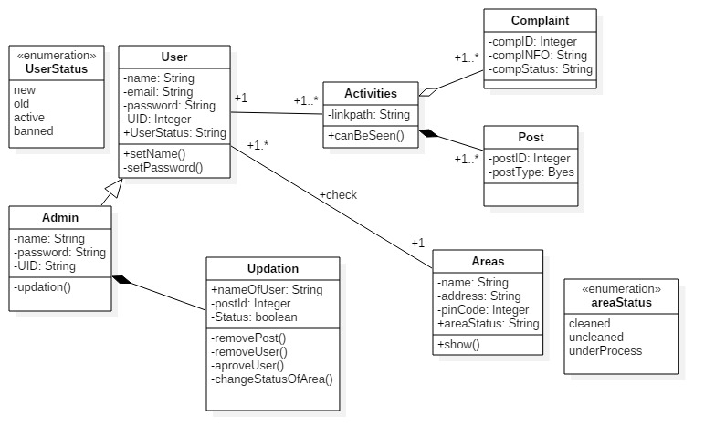

Fig no. 3.0 - Class Diagram

A class diagram in the Unified Modeling Language (UML) is a type of static structure diagram that describes the structure of a system by showing the system's classes, their attributes, operations (or methods), and the relationships among objects.

**Classes**: A class represents an object or a set of objects that share a common structure and behavior. They're represented with a rectangle that includes rows of the class name, its attributes, and its operations. When drawing a class diagram on a class diagram, only the top row must be filled out. In our project classes names are user, activities, areas, admin, updation, status.

**Data types** - Classifiers that define data values. Data types can model both primitive types,non-primitives and enumerations. In this project string, byte, integer, Boolean are used.

**Interfaces**- Similar to a class, except that a class can have an instance of its type, and an interface must have at least one class to implement it.

**Enumerations** - Representations of user-defined data types. An enumeration includes groups of identifiers that represent values of the enumeration.

**Objects** - Instances of a class or classes. Objects can be added to a class diagram when representing either concrete or prototypical instances

**4.4 E-R Diagram**

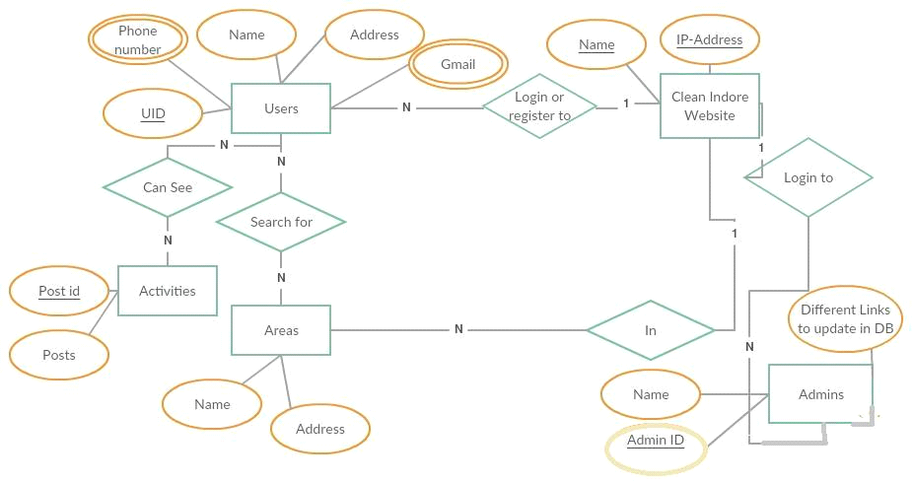

Fig no.4.0 - ER-Diagram

ER-Diagram is a visual representation of data that describes how data is related to each other.

In this project few symbols and notations are used to create E-R Diagram.

**Entity:**An **Entity** can be any object, place, person or class. In E-R Diagram, an **entity** is represented using rectangles. Ex: users, areas, activities, admin, clean Indore Website.



**Attribute:**An **Attribute** describes a property or characteristic of an entity. Ex: name, address etc.



**Key Attribute:** Key attribute represents the main characterstic of an Entity. It is used to represent Primary key. Ellipse with underlying lines represent Key Attribute.Ex:PostId,IP etc

**Relationship:** A Relationship describes relations between entities. Relationship is represented using diamonds.



**Multivalued Attribute:** A multivalued attribute can have more than one value at a time for an attribute.



**CHAPTER-5 Implementation and Testing**

**Unit Testing**

Unit testing is the testing of an individual unit or group of related units. It falls under the class of white box testing. It is often done by the programmer to test that the unit he/she has implemented is producing expected output against given input.

**Integration Testing**

Integration testing is testing in which a group of components are combined to produce output. Also, the interaction between software and hardware is tested in integration testing if software and hardware components have any relation. It may fall under both white box testing and black box testing.

**Functional Testing**

Functional testing is the testing to ensure that the specified functionality required in the system requirements works. It falls under the class of black box testing.

**System Testing**

System testing is the testing to ensure that by putting the software in different environments (e.g., Operating Systems) it still works. System testing is done with full system implementation and environment. It falls under the class of black box testing.

**Stress Testing**

Stress testing is the testing to evaluate how system behaves under unfavorable conditions. Testing is conducted at beyond limits of the specifications. It falls under the class of black box testing.

**Performance Testing**

Performance testing is the testing to assess the speed and effectiveness of the system and to make sure it is generating results within a specified time as in performance requirements. It falls under the class of black box testing.

**CHAPTER– 6 Conclusion**

The basic idea behind making this project is to provide ease of access to the customers by providing a Digital platform, through which they can easily access the details of SAFAI.in project. In this project we have tried to introduce the online facilities such as online details of the project, detailed description of the working structures, through all these facilities we will be able to maintain proper database of the zones and buses, the system also provides the facility of the backup as per the requirement. Clean Indore website will be helpful for awareness for cleaning among people.

This website will helpful and Indore will remain No. 1 in swachh bharat campaign.

**REFERENCES**

[1]SwachBharat

[http://www.swachhbharaturban.in](http://www.swachhbharaturban.in/)and[https://swachhbharat.mygov.in](https://swachhbharat.mygov.in/)

[2]XAMPP

[https://www.apachefriends.org](https://www.apachefriends.org/)

[3]HTML And CSS

[https://www.w3schools.com](https://www.w3schools.com/)

[4]PHP

<https://www.tutorialspoint.com/php/index.htm>

[5] Indore 311, Android application

which is available on Google Play Store, from Civic Solution Pvt. Ltd.

[6] Swachchh Indore, Android application

which is available on Google Play Store, from Quacito/INFOCRATS

[7] Activity Diagrams

https://en.wikipedia.org/wiki/Activity_diagram

[8] Sequence Diagrams

[https://en.wikipedia.org/wiki/Sequence_diagram](https://en.wikipedia.org/wiki/Sequence_diagram%20HYPERLINK%20%22https://en.wikipedia.org/wiki/Sequence_diagram%22)

[9] MySQL

[https://www.mysql.com/](https://www.mysql.com/%20HYPERLINK%20%22https://www.mysql.com/%22)